climate negotiators

Start of Block: Default Question Block

Q1 Welcome to this survey!   
  
 This survey is anonymous and is conducted for research purposes.   
  
 It takes about 5 min to complete.

Q4 Click to write the question text

Browser (1)

Version (2)

Operating System (3)

Screen Resolution (4)

Flash Version (5)

Java Support (6)

User Agent (7)

End of Block: Default Question Block

Start of Block: Block 3

Q11 What is the best climate treaty that could happen?

________________________________________________________________

________________________________________________________________

________________________________________________________________

________________________________________________________________

________________________________________________________________

End of Block: Block 3

Start of Block: GCP

Q3 The survey is about a **Global Climate Plan** (GCP). Please read carefully its description below.  
   
 Main principles of the GCP:

**Cap all fossil fuel emissions in accordance with the Paris agreement, using an Emissions Trading Scheme (ETS)**

The plan would define a carbon budget to be broken down into yearly quotas.

CO2 emission permits would be auctioned to emitting companies.

The price of carbon would encourage households and businesses to decarbonize.

The higher prices would ultimately be paid by individuals in proportion to their carbon footprint.

**Use revenue to provide a global basic income and alleviate poverty**

Proceeds would be returned to the public as a basic income for all adults. Each human adult would thus receive approximately $50/month.

Implementation is technically possible (using e.g. smartphones and satellite internet).

**Form a *climate club* with carbon pricing at borders**

The plan would enter into force as soon as the signatory entities cover 60% of global emissions (FYI, China: 30%, EU+UK: 9%, U.S.: 15%, and net beneficiary countries: 23% of total emissions).

Imports to climate club countries would be taxed in proportion to their carbon content.

**Include mechanisms that encourage participation of China, California, etc…**

The Plan would allow states to join the agreement independently of the federal level, in particular by exempting them from border tariffs.

An opt-out clause for the pooling of revenues would allow countries (such as China, South Africa, or Egypt) whose GDP per capita does not exceed the world average by more than 50% to retain revenues collected on their territory, avoiding them being a net contributor despite their above-average carbon footprint.   
   
 **The Plan would operate a redistribution of 1% of global GDP from high-income to lower-income countries.**

The Plan would redistribute from individuals with a high carbon footprint to those with a low footprint. Individuals at the world average carbon footprint would neither win nor lose.

At their plateau, between 2030 and 2050, revenues would correspond to approximately 5% of world GDP, including 1% in net transfers between countries.

The basic income would lift the 700 million living under $2/day out of extreme poverty.

These estimates were computed with the central IPCC +2°C scenario, which implies a carbon price of around $150/tCO2 in 2030, $200 in 2040, $400 in 2050, and net-zero in 2070.

Q5 Gains (in blue) and losses (in red) by country from the Global Climate Plan, in 2040:

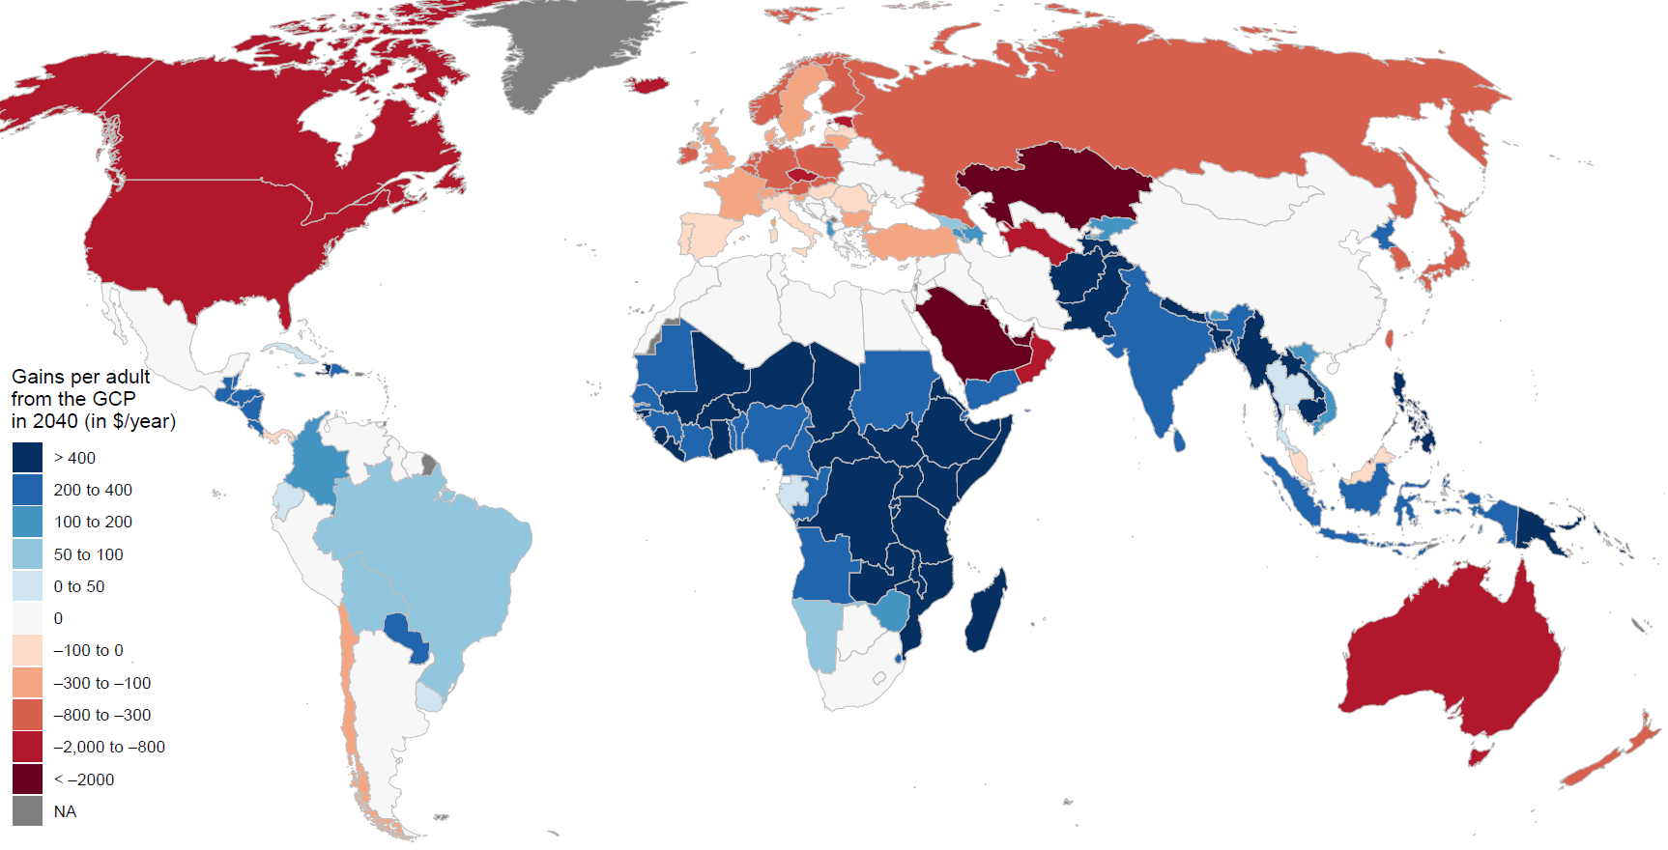

Q6 Gains (in blue) and losses (in red) by country from the Global Climate Plan, aggregated throughout the 21st century:

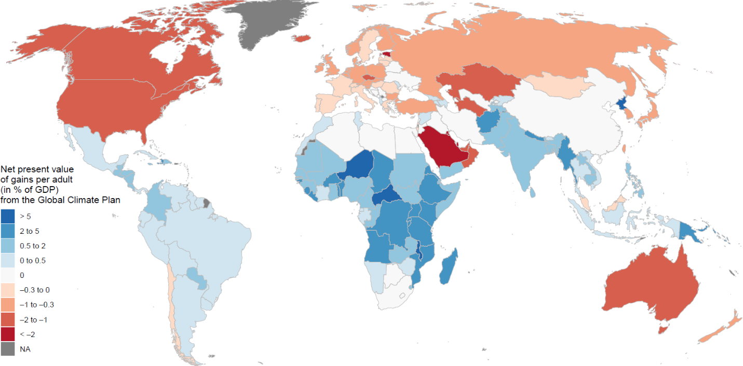

Q7 Do you *personally* support or oppose the Global Climate Plan?

* Strongly support (1)
* Somewhat support (2)
* Indifferent or Prefer not to say (3)
* Somewhat oppose (4)
* Strongly oppose (5)

Q8 Among the entities below, which ones would participate in the Global Climate Plan?  
*More precisely, for which entities is participation more likely than not? We are appealing to your best educated guess. Consider that current governments would take the decision.*

* China (1)
* The United States of America (2)
* The European Union (3)
* India (4)
* Russia (5)
* The African Union (6)
* Japan (7)
* Iran (8)
* Indonesia (9)
* Saudi Arabia (10)
* Canada (11)
* Brazil (12)
* Australia (13)
* California (14)
* Your own country (15)

Q15 Among the entities below, in which ones would there be majority support for the Global Climate Plan among the population?  
*We are appealing to your best educated guess.*

* China (1)
* The United States of America (2)
* The European Union (3)
* India (4)
* Russia (5)
* The African Union (6)
* Japan (7)
* Iran (8)
* Indonesia (9)
* Saudi Arabia (10)
* Canada (11)
* Brazil (12)
* Australia (13)
* California (14)
* Your own country (15)

Q9 What are the pros and cons of the Global Climate Plan?

________________________________________________________________

________________________________________________________________

________________________________________________________________

________________________________________________________________

________________________________________________________________

Q10 How could the Global Climate Plan be improved?   
*You can leave the field empty if you do not have suggestions or think that the Global Climate Plan is not worth pursuing.*

________________________________________________________________

________________________________________________________________

________________________________________________________________

________________________________________________________________

________________________________________________________________

End of Block: GCP

Start of Block: Personal information

Q13 How well-informed are you about your government's views on climate negotiations?

* Perfectly informed (1)
* Well informed (2)
* Somewhat aware (3)
* Not aware at all (4)

|  |
| --- |
|  |

country What is your country?

▼ Prefer not to say (1358) ... Zimbabwe (1357)

Display This Question:

If List of Countries = Prefer not to say

Q17 According to the previous page, would your country gain or lose from the Global Climate Plan?

* Gain a lot (1)
* Gain somewhat (2)
* Neither gain nor lose (3)
* Lose somewhat (4)
* Lose a lot (5)

Q16 What is your position?

* Lead climate negotiator, Minister or Vice-minister (1)
* Climate negotiator (2)
* Government employee (3)
* Scholar (4)
* NGO employee (5)
* Other (6)

Q18 How old are you?

* Below 35 (1)
* 35 to 50 (2)
* 51 to 65 (3)
* Above 65 (4)

Q13 The survey is nearing completion. You can now enter any comments, thoughts or suggestions in the field below.

________________________________________________________________

________________________________________________________________

________________________________________________________________

________________________________________________________________

________________________________________________________________

Q14 If you wish to support or oppose the Global Carbon Plan publicly or want to be informed of the survey results, you can leave your email address below, or email global.climate.scheme@gmail.com, with the keywords "support", "oppose" and/or "results".

________________________________________________________________

End of Block: Personal information